Data Warehousing and Business Intelligence



Assignment 2

Hassan Younas
21I-1788

Question 1

Array Representation:

1. Product Dimension
- Attributes:
  - ProductID: Unique identifier for each product.
  - ProductName: Name or description of the product (e.g., Room Type).
  - Category: Type of product (e.g., Deluxe Room, Suite, Standard Room).
  - Price: Cost associated with the product (e.g., room price per night).
  - Features: Specific attributes associated with the product (e.g., view type, floor level).
- Relationship: Each room (ProductID) belongs to a specific category and has unique features such as price, view type, and floor level.

2. Time Dimension
- Attributes:
  - Date: Specific date (e.g., check-in date).
  - Month: Month of the booking or transaction.
  - Quarter: Quarter of the year (Q1, Q2, Q3, Q4).
  - Year: Year of the transaction.
  - Day of the Week: Useful for analyzing trends on specific weekdays.
- Relationship: Each booking or transaction occurs on a specific date, which is part of a larger month, quarter, and year hierarchy.

3. Region Dimension
- Attributes:
  - RegionID: Unique identifier for each region.
  - RegionName: Name of the region (e.g., North, East).
  - Country: Country associated with the region.
  - State: State within the country.
  - City: City within the state.
  - Postal Code: Specific postal or ZIP code for more granular location data.
- Relationship: Each region (RegionID) maps to a specific country, state, and city, helping localize bookings geographically.

Measures Associated with Dimensions
The measures we track in this array structure are:
- TotalBookings: Total number of bookings in a specific cell.
- Revenue: Total revenue generated in a specific cell.

MDB Array Representation
This MDB array structure can be visualized as a 3D array where each cell is defined by coordinates along the three dimensions:
- Product Dimension (i): Represents each unique room type.
- Time Dimension (j): Represents each specific date.
- Region Dimension (k): Represents each unique region or geographical area.
Each cell (i, j, k) in the array contains the values of TotalBookings and Revenue specific to that Product, Time, and Region combination.
Example Cell
Consider the following example cell within the array:
- Example Cell (Suite Room, 2024-04-10, New York City):
  - TotalBookings: 15
  - Revenue: $4,500
In this example, (Suite Room, 2024-04-10, New York City) corresponds to bookings for the Suite room type on April 10, 2024, in New York City, with a total of 15 bookings generating $4,500 in revenue.

Linearization:

Example Cell
Let’s choose a specific cell within the multidimensional array with the following details:
- Room Type (Product): Suite
- Check-in Date (Time): April 10, 2024
- Region: New York City
This cell represents the booking count and revenue for a "Suite" room type on April 10, 2024, in New York City.

Linearization Process
We assume that each dimension has an array of indices, where:
- Product (Room Type) has a size of D1D_1D1​
- Time (Check-in Date) has a size of D2D_2D2​
- Region has a size of D3D_3D3​
For a cell located at indices iii, jjj, and kkk in the Product, Time, and Region dimensions, respectively, we use the following linearization formula:
Linearized Index=i+(j×D1)+(k×D1×D2)\text{Linearized Index} = i + (j \times D_1) + (k \times D_1 \times D_2)Linearized Index=i+(j×D1​)+(k×D1​×D2​)
where:
- iii is the index of the chosen Room Type (Product) dimension.
- jjj is the index of the chosen Time dimension (specific date).
- kkk is the index of the chosen Region dimension.

Step-by-Step Linearization Calculation
- Product Dimension (D1): 10 unique room types
- Time Dimension (D2): 365 days in a year
- Region Dimension (D3): 50 unique regions
- Index of "Suite" room type: i=2i = 2i=2 (assuming "Suite" is the third room type in the list, zero-based indexing)
- Index for "April 10, 2024" in Time: j=100j = 100j=100 (assuming this is the 101st day in the year)
- Index for "New York City" in Region: k=5k = 5k=5 (assuming NYC is the 6th region in the list)

Using the linearization formula:
Linearized Index=2+(100×10)+(5×10×365)\text{Linearized Index} = 2 + (100 \times 10) + (5 \times 10 \times 365)Linearized Index=2+(100×10)+(5×10×365)
Calculating each term:
- First Term: i=2i = 2i=2
- Second Term: j×D1=100×10=1000j \times D_1 = 100 \times 10 = 1000j×D1​=100×10=1000
- Third Term: k×D1×D2=5×10×365=18250k \times D_1 \times D_2 = 5 \times 10 \times 365 = 18250k×D1​×D2​=5×10×365=18250
Now, summing these terms gives:
Linearized Index=2+1000+18250=19252\text{Linearized Index} = 2 + 1000 + 18250 = 19252Linearized Index=2+1000+18250=19252

So, the linearized index for the cell representing bookings for a "Suite" room on "April 10, 2024," in "New York City" is 19252.

Generalization:

General Linearization Formula for 'n' Dimensions:
Linear Index=∑n​(Index_i​×Product of sizes of subsequent dimensions)
where:
- Index_i​ is the position within the i-th dimension.
- Product of sizes of subsequent dimensions is the product of the sizes of all dimensions after the i-th dimension, representing the total number of combinations possible along those dimensions.

Complex queries, like calculating total revenue for all rooms during peak seasons, are efficiently managed through array structures and linearization by enabling direct access to relevant data points. In a linearized array, peak season dates and room types correspond to specific indices, allowing us to quickly locate and aggregate revenue values for only those indices. This structure bypasses the need for multi-dimensional joins or iterative loops, making data retrieval faster and simplifying complex queries. Thus, array structures and linearization streamline accessing and summing revenue data, ensuring high efficiency in processing peak season totals.

Question 2

Snowflake Diagram
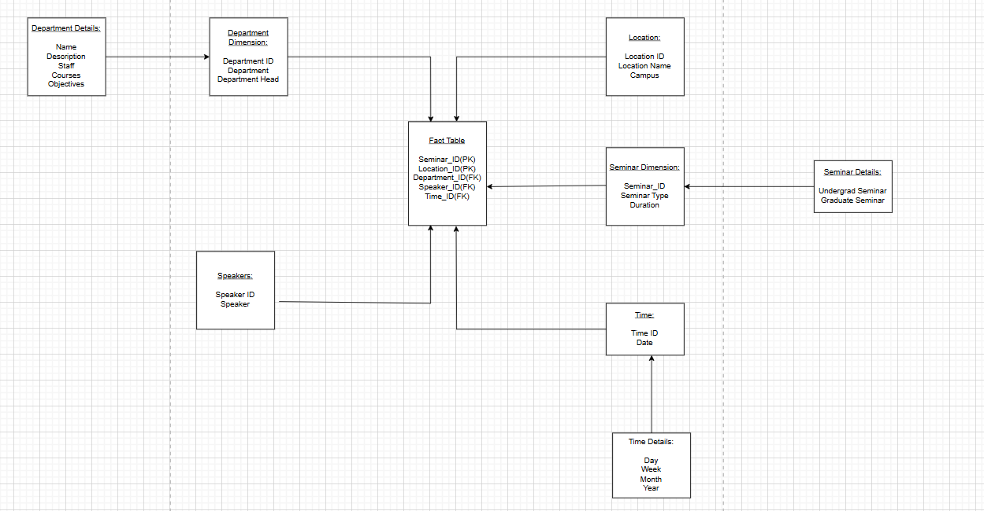

Star Diagram
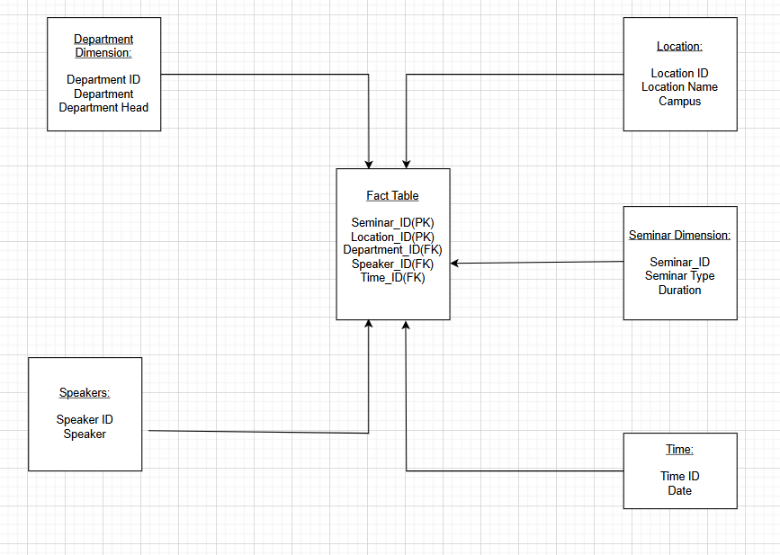

The Star Schema is more effective for the University Research Seminar Series because it simplifies queries by directly linking a central fact table to denormalized dimension tables (e.g., Speaker, Department, Location, Time). This reduces joins, speeds up query performance, and makes data retrieval easier for reporting and analysis. The Snowflake Schema, though more normalized, would require more joins, slowing queries and adding complexity, which is less ideal for the frequent, straightforward queries typical in this academic context.

Question 3

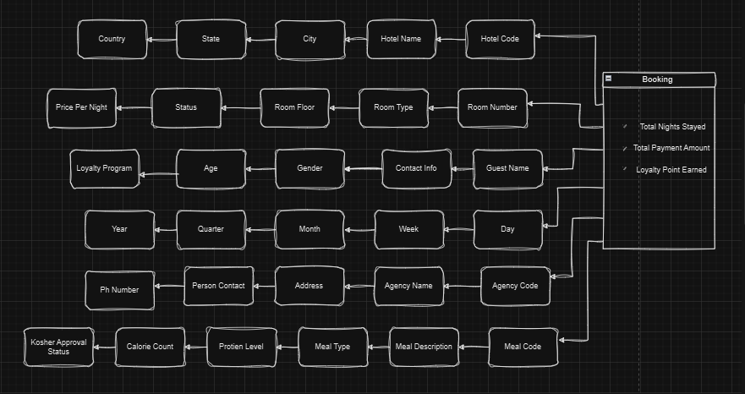

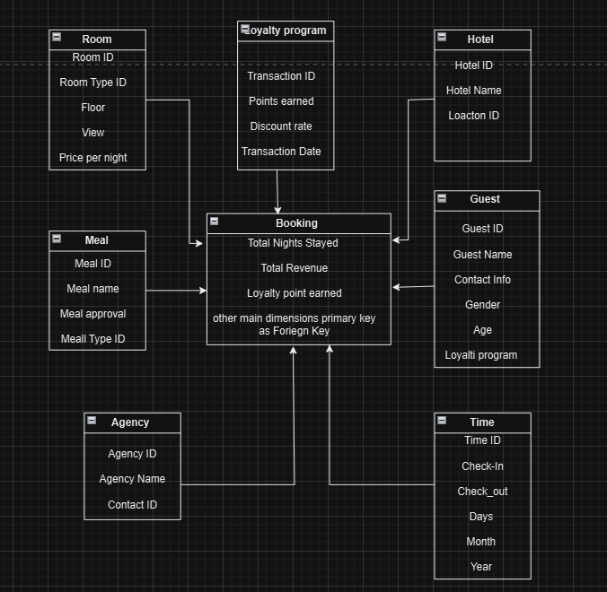
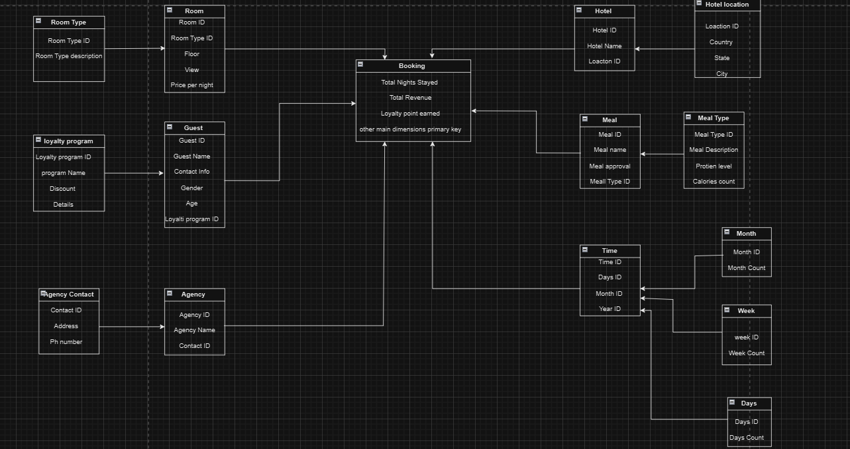

Question 4

